[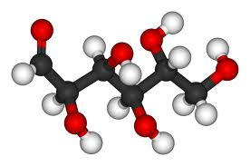](http://www.google.com/url?sa=i&rct=j&q=&esrc=s&frm=1&source=images&cd=&cad=rja&uact=8&docid=iBwfFL1dK9cAgM&tbnid=SzlBQ2qWJw1G4M:&ved=0CAUQjRw&url=http%3A%2F%2Fchromium-polynicotinate-supplement.blogspot.com%2F2012%2F06%2Fchromium-polynicotinate-weight-control_17.html&ei=_Eo7U8WKC8X32QX01oGgDg&bvm=bv.63934634,d.b2I&psig=AFQjCNE5DVrA-dHEw5f4TGq3p0hQlDbBag&ust=1396481111641065)

C6H12O6

[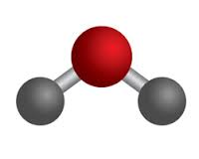](http://www.google.com/url?sa=i&rct=j&q=&esrc=s&frm=1&source=images&cd=&cad=rja&uact=8&docid=R0q5Uq54sNnhuM&tbnid=2XtkvFHfL03CVM:&ved=0CAUQjRw&url=http%3A%2F%2Fwww.middleschoolchemistry.com%2Flessonplans%2Fchapter2%2Flesson2&ei=W0s7U9m0GMzy2gXVhICoCw&bvm=bv.63934634,d.b2I&psig=AFQjCNEHq9Ez9Zio10LbtKNq4HKHVGR0Qw&ust=1396481224820762)

H2O

H2O

[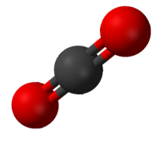](http://www.google.com/url?sa=i&rct=j&q=&esrc=s&frm=1&source=images&cd=&cad=rja&uact=8&docid=TlmTuwUK-zQi3M&tbnid=363XjkZVA-5MmM:&ved=0CAUQjRw&url=http%3A%2F%2Fsansscience.wordpress.com%2F2011%2F07%2F24%2Ftony-abbott-wins-sans-science-comment-of-the-month-on-co2-emissions%2F&ei=FU07U73iO4v12QWx0YDQAg&bvm=bv.63934634,d.b2I&psig=AFQjCNFCYANNdzXwX3vqUymv19VGwENdZQ&ust=1396481620251462)

CO2

CO2

[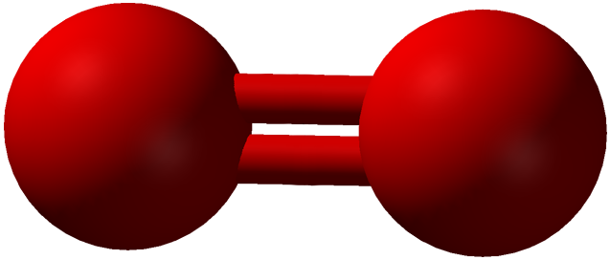](http://www.google.com/url?sa=i&rct=j&q=&esrc=s&frm=1&source=images&cd=&cad=rja&uact=8&docid=Qokvqhz0vFvMjM&tbnid=GXUxE5DGETKokM:&ved=0CAUQjRw&url=http%3A%2F%2Fscientificgems.wordpress.com%2Ftag%2Fpropane%2F&ei=bE47U9z6HKLs2QXCl4GgCA&bvm=bv.63934634,d.b2I&psig=AFQjCNHjFakgXFL0xsB9FK25kYXK7AGFag&ust=1396482005690923)

O2

O2

[](http://www.google.com/url?sa=i&rct=j&q=&esrc=s&frm=1&source=images&cd=&cad=rja&uact=8&docid=Qokvqhz0vFvMjM&tbnid=GXUxE5DGETKokM:&ved=0CAUQjRw&url=http%3A%2F%2Fscientificgems.wordpress.com%2Ftag%2Fpropane%2F&ei=bE47U9z6HKLs2QXCl4GgCA&bvm=bv.63934634,d.b2I&psig=AFQjCNHjFakgXFL0xsB9FK25kYXK7AGFag&ust=1396482005690923)

O2

O2

[](http://www.google.com/url?sa=i&rct=j&q=&esrc=s&frm=1&source=images&cd=&cad=rja&uact=8&docid=Qokvqhz0vFvMjM&tbnid=GXUxE5DGETKokM:&ved=0CAUQjRw&url=http%3A%2F%2Fscientificgems.wordpress.com%2Ftag%2Fpropane%2F&ei=bE47U9z6HKLs2QXCl4GgCA&bvm=bv.63934634,d.b2I&psig=AFQjCNHjFakgXFL0xsB9FK25kYXK7AGFag&ust=1396482005690923)

O2

O2

[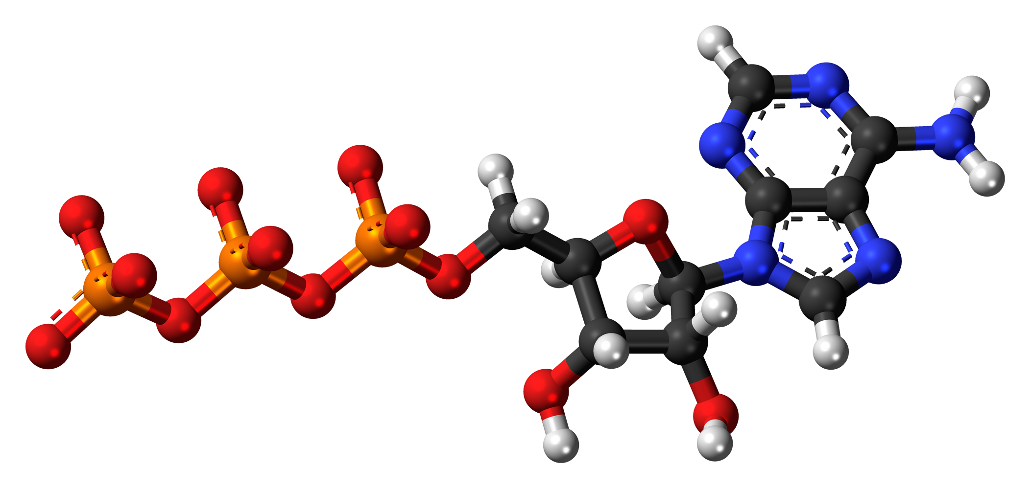](http://www.google.com/url?sa=i&rct=j&q=&esrc=s&frm=1&source=images&cd=&cad=rja&uact=8&docid=8R8mCS3yBDH_1M&tbnid=rkffn3Kd-Er6DM:&ved=0CAUQjRw&url=http%3A%2F%2Fcommons.wikimedia.org%2Fwiki%2FFile%3AAdenosine-triphosphate-anion-3D-balls.png&ei=c087U4GuI8rx2AWzpIGgDA&bvm=bv.63934634,d.b2I&psig=AFQjCNGb_FGTZ4LExSFNta2K2KT65nNtFw&ust=1396482255200011)

ATP (energy)

[](http://www.google.com/url?sa=i&rct=j&q=&esrc=s&frm=1&source=images&cd=&cad=rja&uact=8&docid=HOguABGucM1SiM&tbnid=5XZuY1s6_u4vwM:&ved=0CAUQjRw&url=http%3A%2F%2Fkeithpaulcook.wordpress.com%2Fsunlight-in-a-jar%2F&ei=_E87U7iVHues2wWlrICwBw&bvm=bv.63934634,d.b2I&psig=AFQjCNFo9ex0mrJwgrhhEZWMReeGL0Fx5Q&ust=1396482385440992)

SUNLIGHT